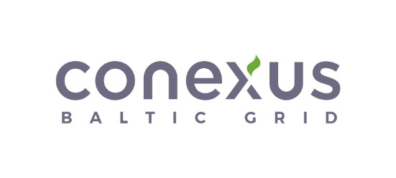

**APPLICATION FOR THE**

**NATURAL GAS TRANSFER TO 2025/2026 CYCLE**

|  |  |
| --- | --- |
| Date___/____/_______ |  |

In the accordance with the Regulations Regarding the Use of Inčukalns Underground Gas

Storage Facility, Annex 2, Section 6.12.,

|  |  |
| --- | --- |
| network user (company name): |  |
|  |  |
| energy identification code (EIC): |  |

is transferring natural gas in 2-year bundled capacity product and Stock transfer product, kWh:

|  |  |  |  |  |
| --- | --- | --- | --- | --- |
| From To | IPGK1YP | IPGK2YP | IPGK5YP | INTP |
| IPGK2YP 2023/2025 |  |  |  |  |
| IPGK2YP 2024/2026 |  |  |  |  |
| INTP |  |  |  |  |

In Bundled capacity product, kWh:

|  |  |  |
| --- | --- | --- |
| From | To | Amount, kWh |
| IPGK1YP | IPGK1YP 2025/2026 | Whole amount or |
| …………….kWh |
| IPGK2YP 2024/2026 | Whole amount or |
| …………….kWh |
| IPGK5YP | Whole amount or |
| …………….kWh |
| INTP | Whole amount or |
| …………….kWh |

Document to be uploaded in Common zone Platform, recipient Conexus Baltic Grid AS [21X000000001379R]