Masanobu Furuya
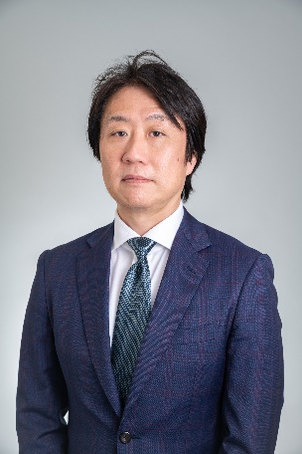

CAREER
Since 2019
MM Capital Partners Co., Ltd. – COO, Head of Investment Group (Tokyo)
2013 – 2019
Marubeni Corporation – Manager, Transport Infrastructure (Tokyo)
2009 – 2013
Marubeni Corporation – Manager, Emission Trading (Tokyo)
2005 – 2009
Marubeni America Corporation – Director, Venture Capital (New York, Silicon Valley)
2001 – 2005
Marubeni Corporation – Manager, Venture Investment (Tokyo)
1999 – 2001
Marubeni Corporation – Assistant Manager, Electronic Materials (Tokyo)
EDUCATION
1997 – 1999
M.S. Applied Chemistry, Keio University (Yokohama)
1993 – 1997
B.S. Applied Chemistry, Keio University (Yokohama)

